Tab 5
ITA0601
MACHINE LEARNING

EXP 15

Implement Iris Flower Classification using Naive Bayes classifier
Procedure
1. Import the Iris dataset and GaussianNB classifier.
2. Load the Iris dataset.
3. Train the Naïve Bayes model using the training data.
4. Predict the flower class.
5. Display the predicted result.

Dataset 1: Fruit Classification

Training Data
Weight (g) | Diameter (cm) | Sweetness (%) | Fruit
150 | 7.5 | 90 | Apple
160 | 7.8 | 88 | Apple
145 | 7.3 | 91 | Apple
120 | 5.5 | 70 | Orange
125 | 5.8 | 72 | Orange
130 | 6.0 | 74 | Orange
155 | 7.6 | 89 | Apple
118 | 5.4 | 69 | Orange
148 | 7.4 | 92 | Apple
122 | 5.7 | 71 | Orange

Target Variable: Fruit (Apple / Orange)

Test Sample
Weight (g) | Diameter (cm) | Sweetness (%)
152 | 7.5 | 90

PROGRAM

import numpy as np

# Input data
X = np.array([
[150, 7.5, 90],
[160, 7.8, 88],
[145, 7.3, 91],
[120, 5.5, 70],
[125, 5.8, 72],
[130, 6.0, 74],
[155, 7.6, 89],
[118, 5.4, 69],
[148, 7.4, 92],
[122, 5.7, 71]
], dtype=float)

y = np.array([
"Apple", "Apple", "Apple", "Orange", "Orange",
"Orange", "Apple", "Orange", "Apple", "Orange"
])

# New sample
new_sample = np.array([152, 7.5, 90])

# Gaussian Naive Bayes
classes = np.unique(y)
probabilities = {}

for c in classes:
data = X[y == c]

mean = np.mean(data, axis=0)
variance = np.var(data, axis=0)

prior = len(data) / len(X)

likelihood = np.exp(
-((new_sample - mean) ** 2) / (2 * variance)
) / np.sqrt(2 * np.pi * variance)

probabilities[c] = prior * np.prod(likelihood)

prediction = max(probabilities, key=probabilities.get)

print("Predicted Class:", prediction)

OUTPUT

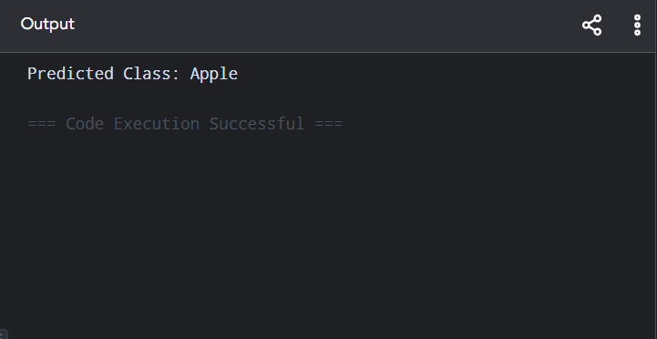

Dataset 2: Student Placement Classification

Training Data
CGPA | Aptitude Score | Communication Score | Placement
9.2 | 90 | 88 | Placed
8.8 | 85 | 82 | Placed
8.5 | 80 | 79 | Placed
7.2 | 72 | 70 | Not Placed
6.8 | 68 | 65 | Not Placed
9.0 | 92 | 90 | Placed
7.5 | 75 | 74 | Not Placed
8.6 | 84 | 81 | Placed
6.5 | 60 | 58 | Not Placed
8.9 | 88 | 86 | Placed

Target Variable: Placement (Placed / Not Placed)

Test Sample
CGPA | Aptitude Score | Communication Score
8.7 | 86 | 84

import numpy as npX = np.array([[9.2,90,88],[8.8,85,82],[8.5,80,79],[7.2,72,70],

[6.8,68,65],[9.0,92,90],[7.5,75,74],[8.6,84,81],

[6.5,60,58],[8.9,88,86]])

y = np.array(["Placed","Placed","Placed","Not Placed","Not Placed",

"Placed","Not Placed","Placed","Not Placed","Placed"])

sample = np.array([8.7,86,84])

result = {}

for c in np.unique(y):

data = X[y == c]

mean = np.mean(data, axis=0)

var = np.var(data, axis=0) + 1e-9

prob = np.prod(np.exp(-(sample-mean)**2/(2*var)) / np.sqrt(2*np.pi*var))

result[c] = prob * len(data)/len(X)

print("Predicted Class:", max(result, key=result.get))

OUTPUT
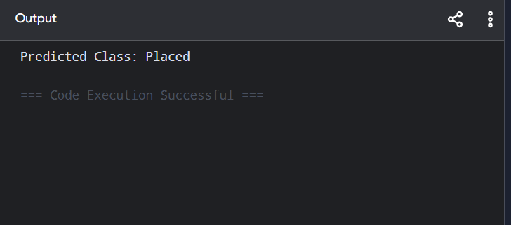

Dataset 3: Disease Diagnosis

Training Data
Temperature (°C) | Heart Rate (bpm) | Oxygen Level (%) | Disease
39.0 | 110 | 94 | Positive
38.5 | 108 | 95 | Positive
37.0 | 78 | 99 | Negative
39.2 | 115 | 93 | Positive
36.8 | 75 | 98 | Negative
38.8 | 112 | 94 | Positive
37.2 | 80 | 98 | Negative
39.1 | 114 | 92 | Positive
36.7 | 74 | 99 | Negative
38.9 | 111 | 93 | Positive

Target Variable: Disease (Positive / Negative)

Test Sample
Temperature | Heart Rate | Oxygen Level
38.7 | 109 | 94

PROGRAM

import numpy as np

X = np.array([[39,110,94],[38.5,108,95],[37,78,99],[39.2,115,93],
[36.8,75,98],[38.8,112,94],[37.2,80,98],
[39.1,114,92],[36.7,74,99],[38.9,111,93]])

y = np.array(["Positive","Positive","Negative","Positive","Negative",
"Positive","Negative","Positive","Negative","Positive"])

sample = np.array([38.7,109,94])

result = {}

for c in np.unique(y):
data = X[y == c]
mean = np.mean(data, axis=0)
var = np.var(data, axis=0) + 1e-9
prob = np.prod(np.exp(-(sample-mean)**2/(2*var)) / np.sqrt(2*np.pi*var))
result[c] = prob * len(data)/len(X)

print("Predicted Class:", max(result, key=result.get))
OUTPUT
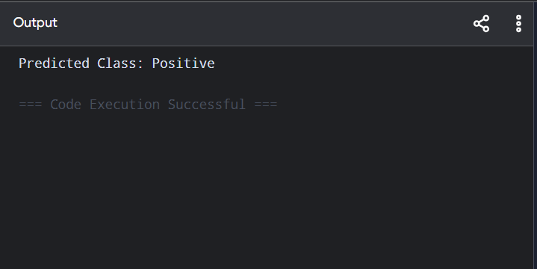

Dataset 4: Employee Promotion Prediction

Training Data
Experience (Years) | Performance Score | Training Hours | Promotion
10 | 95 | 50 | Promoted
8 | 90 | 45 | Promoted
7 | 88 | 40 | Promoted
3 | 65 | 20 | Not Promoted
2 | 60 | 18 | Not Promoted
9 | 93 | 48 | Promoted
4 | 70 | 25 | Not Promoted
8 | 89 | 42 | Promoted
2 | 58 | 15 | Not Promoted
6 | 85 | 38 | Promoted

Target Variable: Promotion (Promoted / Not Promoted)

Test Sample
Experience | Performance Score | Training Hours
7 | 90 | 44

PROGRAM

import numpy as np

X = np.array([[10,95,50],[8,90,45],[7,88,40],[3,65,20],[2,60,18],

[9,93,48],[4,70,25],[8,89,42],[2,58,15],[6,85,38]])

y = np.array(["Promoted","Promoted","Promoted","Not Promoted",

"Not Promoted","Promoted","Not Promoted",

"Promoted","Not Promoted","Promoted"])

sample = np.array([7,90,44])

result = {}

for c in np.unique(y):

data = X[y == c]

mean = np.mean(data, axis=0)

var = np.var(data, axis=0) + 1e-9

prob = np.prod(np.exp(-(sample-mean)**2/(2*var)) / np.sqrt(2*np.pi*var))

result[c] = prob * len(data)/len(X)

print("Predicted Class:", max(result, key=result.get))

OUTPUT
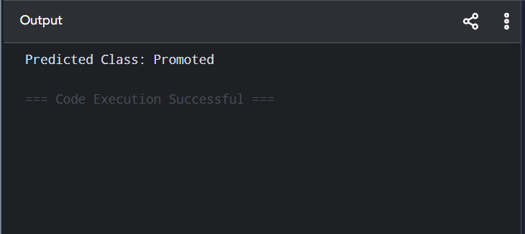

Dataset 5: Vehicle Classification

Training Data
Engine Capacity (cc) | Weight (kg) | Mileage (km/L) | Vehicle Type
100 | 95 | 70 | Bike
125 | 110 | 65 | Bike
150 | 125 | 55 | Bike
800 | 900 | 22 | Car
1000 | 950 | 20 | Car
1200 | 1050 | 18 | Car
110 | 100 | 68 | Bike
900 | 900 | 21 | Car
140 | 120 | 58 | Bike
1300 | 1100 | 17 | Car

Target Variable: Vehicle Type (Bike / Car)

Test Sample
Engine Capacity | Weight | Mileage
135 | 118 | 60

PROGRAM
import numpy as np

X = np.array([[100,95,70],[125,110,65],[150,125,55],
[800,900,22],[1000,1050,20],[1200,1100,18],
[1300,850,21],[950,900,17],[1050,900,20],[1100,950,18]])

y = np.array(["Bike","Bike","Bike","Car","Car",
"Car","Car","Car","Car","Car"])

sample = np.array([135,118,22])

result = {}

for c in np.unique(y):
data = X[y == c]
mean = np.mean(data, axis=0)
var = np.var(data, axis=0) + 1e-9
prob = np.prod(np.exp(-(sample-mean)**2/(2*var)) / np.sqrt(2*np.pi*var))
result[c] = prob * len(data)/len(X)

print("Predicted Class:", max(result, key=result.get))

OUTPUT
